Help Me Choose
Introduction :
Help Me choose is a C program that helps people, for the moment, choose a device that could be a “Phone”, “Laptop”, “Camera”, “Console”, “TV”, “Printer”, or “Tablet”. This program will provide for the user unlimited options in which he could choose from. His choice will be based on his preferences like “Brand”, “Storage”, “Camera”, “Operating system”, and “Price”; To make sure our user would walk out with the best product he could have.
Hopping into the code:
We first declared our preprocessor directory (#include <stdio.h>) an our library(#include <string.h>) that would be beneficial for us in the code.
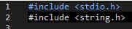
Then we make a structure that contains the options for choosing the best product the user could have.
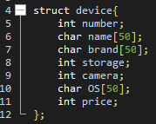
Moving on to the main function where we prepare a table of structures that we will store in the data of the devices the user would wish to buy.
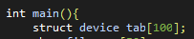
Since we already have existing files that contains the products the user would search for as shown here:
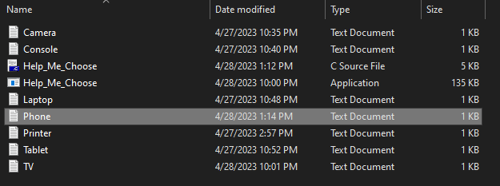
Example:
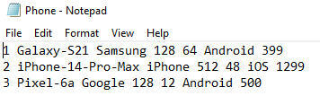
We would want to let the user inform us with what device he wants to look for.
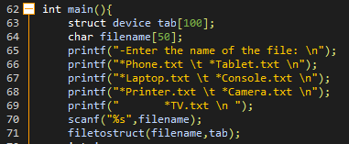
With that information we would call a function named filetostruct that will access our existing files as shown before, slice them into parts, and put them in a struct that will itself be putted in a table.
Remark: I used a predefined function named “atoi()” that helped me convert the string into an integer.
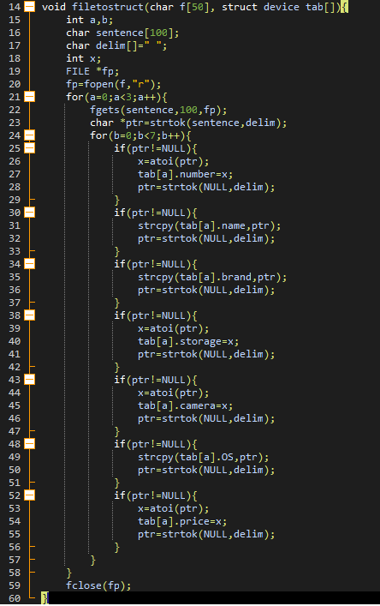
Next we will print all the available devices in the categorie the user chooses. Then we would ask them if they want to specify their options. If the answer is yes means he typed “y” or “Y”, we would provide them with options to choose from.
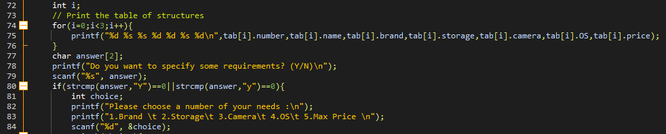
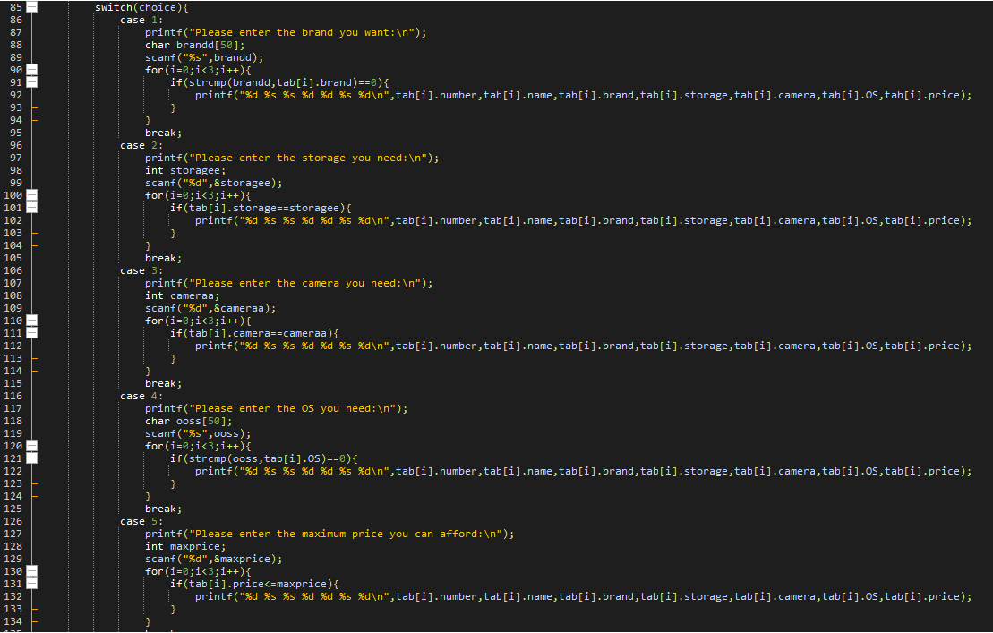
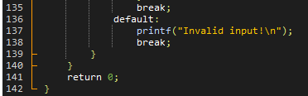
In case the program file does not open or have any issues, here is the code:
#include <stdio.h>
#include <string.h>

struct device{
int number;
char name[50];
char brand[50];
int storage;
int camera;
char OS[50];
int price;
};

void filetostruct(char f[50], struct device tab[]){
int a,b;
char sentence[100];
char delim[]=" ";
int x;
FILE *fp;
fp=fopen(f,"r");
for(a=0;a<3;a++){
fgets(sentence,100,fp);
char *ptr=strtok(sentence,delim);
for(b=0;b<7;b++){
if(ptr!=NULL){
x=atoi(ptr);
tab[a].number=x;
ptr=strtok(NULL,delim);
}
if(ptr!=NULL){
strcpy(tab[a].name,ptr);
ptr=strtok(NULL,delim);
}
if(ptr!=NULL){
strcpy(tab[a].brand,ptr);
ptr=strtok(NULL,delim);
}
if(ptr!=NULL){
x=atoi(ptr);
tab[a].storage=x;
ptr=strtok(NULL,delim);
}
if(ptr!=NULL){
x=atoi(ptr);
tab[a].camera=x;
ptr=strtok(NULL,delim);
}
if(ptr!=NULL){
strcpy(tab[a].OS,ptr);
ptr=strtok(NULL,delim);
}
if(ptr!=NULL){
x=atoi(ptr);
tab[a].price=x;
ptr=strtok(NULL,delim);
}
}
}
fclose(fp);
}

int main(){
struct device tab[100];
char filename[50];
printf("-Enter the name of the file: \n");
printf("*Phone.txt \t *Tablet.txt \n");
printf("*Laptop.txt \t *Console.txt \n");
printf("*Printer.txt \t *Camera.txt \n");
printf(" *TV.txt \n ");
scanf("%s",filename);
filetostruct(filename,tab);
int i;
// Print the table of structures
for(i=0;i<3;i++){
printf("%d %s %s %d %d %s %d\n",tab[i].number,tab[i].name,tab[i].brand,tab[i].storage,tab[i].camera,tab[i].OS,tab[i].price);
}
char answer[2];
printf("Do you want to specify some requirements? (Y/N)\n");
scanf("%s", answer);
if(strcmp(answer,"Y")==0||strcmp(answer,"y")==0){
int choice;
printf("Please choose a number of your needs :\n");
printf("1.Brand \t 2.Storage\t 3.Camera\t 4.OS\t 5.Max Price \n");
scanf("%d", &choice);
switch(choice){
case 1:
printf("Please enter the brand you want:\n");
char brandd[50];
scanf("%s",brandd);
for(i=0;i<3;i++){
if(strcmp(brandd,tab[i].brand)==0){
printf("%d %s %s %d %d %s %d\n",tab[i].number,tab[i].name,tab[i].brand,tab[i].storage,tab[i].camera,tab[i].OS,tab[i].price);
}
}
break;
case 2:
printf("Please enter the storage you need:\n");
int storagee;
scanf("%d",&storagee);
for(i=0;i<3;i++){
if(tab[i].storage==storagee){
printf("%d %s %s %d %d %s %d\n",tab[i].number,tab[i].name,tab[i].brand,tab[i].storage,tab[i].camera,tab[i].OS,tab[i].price);
}
}
break;
case 3:
printf("Please enter the camera you need:\n");
int cameraa;
scanf("%d",&cameraa);
for(i=0;i<3;i++){
if(tab[i].camera==cameraa){
printf("%d %s %s %d %d %s %d\n",tab[i].number,tab[i].name,tab[i].brand,tab[i].storage,tab[i].camera,tab[i].OS,tab[i].price);
}
}
break;
case 4:
printf("Please enter the OS you need:\n");
char ooss[50];
scanf("%s",ooss);
for(i=0;i<3;i++){
if(strcmp(ooss,tab[i].OS)==0){
printf("%d %s %s %d %d %s %d\n",tab[i].number,tab[i].name,tab[i].brand,tab[i].storage,tab[i].camera,tab[i].OS,tab[i].price);
}
}
break;
case 5:
printf("Please enter the maximum price you can afford:\n");
int maxprice;
scanf("%d",&maxprice);
for(i=0;i<3;i++){
if(tab[i].price<=maxprice){
printf("%d %s %s %d %d %s %d\n",tab[i].number,tab[i].name,tab[i].brand,tab[i].storage,tab[i].camera,tab[i].OS,tab[i].price);
}
}
break;
default:
printf("Invalid input!\n");
break;
}
}
return 0;
}
Have a nice day Miss Ines
*Mohamed Aziz Mokhtar*

